Create a Journal for the month of June using the following Transactions table. Click Submit button once you complete.

## TRANSACTIONS TO JOURNALIZE - JUNE

|  |  |
| --- | --- |
| Date | Transactions |
| 6/1 | STS issues common stock for cash investments by owners, $10,000. |
| 6/1 | STS pays for its business license (miscellaneous expense), $50. |
| 6/2 | STS purchases supplies (which will be used up this month) from Capital |
|  | Supply Co. on account for $150. |
| 6/5 | STS works with its first client, Dakota Co, completes the job in one day, and |
|  | receives $200 cash. |
| 6/6 | STS completes work for Jersey Co. and sends them an invoice for $250. |
| 6/8 | STS sends Capital Supply Co. a check for the supplies it purchased on 6/2, $150. |
| 6/9 | STS completes work for Carolina Corp. and sends them an invoice for $450. |
| 6/10 | STS purchases more supplies on account from Office Depot for $40. |
| 6/13 | STS pays its secretary's salary for two weeks, $600. |
| 6/16 | STS completes work for Georgia, Inc. and receives cash payment of $500. |
| 6/17 | STS purchases more supplies (to be used by the end of the month) from Capital |
|  | Supply Co. on account for $30. |
| 6/20 | STS receives a check from Nevada Corporation for the $250 on account. |
| 6/21 | STS pays off the invoice from Office Depot from 6/10 for $40. |
| 6/24 | STS completes work for Minnesota, Inc. and bills them on account for $750. |
| 6/25 | STS' truck expenses are $175 and the company pays all of these in cash. |
| 6/27 | STS pays its secretary's salary for two weeks, $600. |
| 6/29 | STS completes work for York Company and sends them an invoice for $1,600. |
| 6/30 | STS pays cash dividends of $700. |

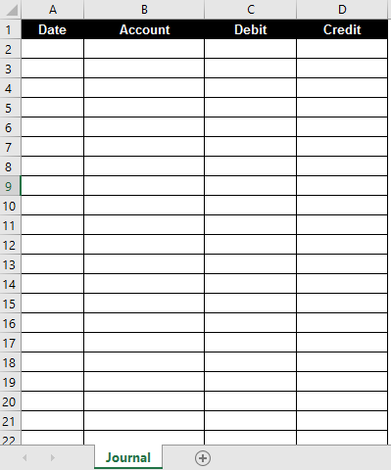

*Sample Sheet  *

*Sample Student Sheet* : 